**Design Decisions**

Leonardo De Morais

Southern New Hampshire University

Dr. Loay Alnaji

June 19th, 2022

**Design Decisions**

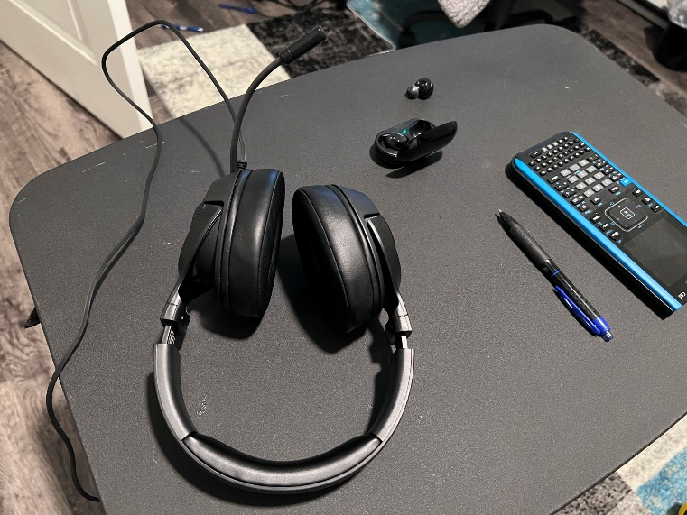**2D image recreated as a 3D scene:**

The objects I recreated as a 3D scene are a scientific calculator, a headphone, an open earbud box with the ear bud inside the box, and a pen. The objects above were designed with more than primitive shapes and are complex objects. The table was designed with a plane as the base for the four items. The pen required three different shapes, an elongated cylinder for the base, a sphere for the clicker, and a cone for the tip of the pen. The headphone was developed using an elongated sphere for the base and a modified sphere to represent the cushion of the headphone. The earbud case was developed using a cylinder for the case, two cylinders for the base of the earbud, and two spheres for the top of the earbud. What's more, the calculator was developed utilizing an elongated rectangular prism and a plane for the screen.

The source of light in my 3D scene is a lantern since it can be moved around the scene and show the reflection of the light on the objects. A user can navigate my 3D world by utilizing the W key to move forward, D to move right, A to move left and S to move backward, what's more, the users can use a combination of mouse and keyboard to move around the scene. One of the easiest ways to introduce a shape into the world was to create header files with different shapes and add those to the main function. In my code, I created several headers such as EarCushion.h to develop the ear cushion for the headphone.

One of the main challenges I had in this course was to add shapes to my world, however, after doing more research and watching all of the videos and materials provided in this class, I was able to understand how to develop different shapes and how to add those shapes to my 3D world. One of the methods I utilized to learn more about OpenGL was to modify existing code and understand the impact of the changes I have caused. This class was one of the hardest classes I have taken, however, after finalizing the project I feel accomplished and I am ready for my next journey.